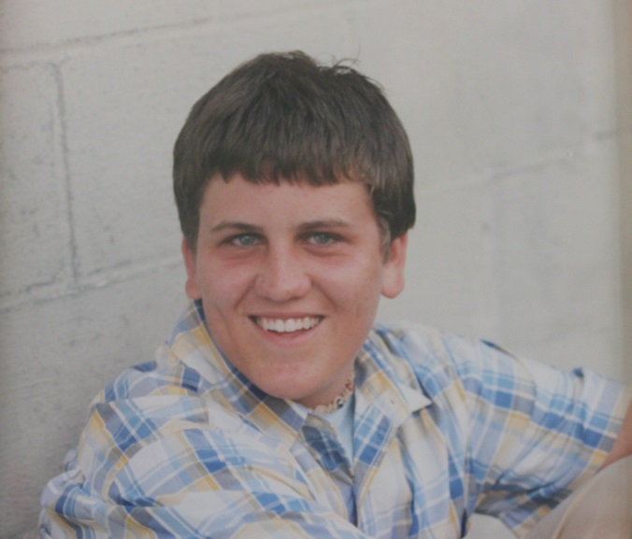

**Joshua David List - 2005**

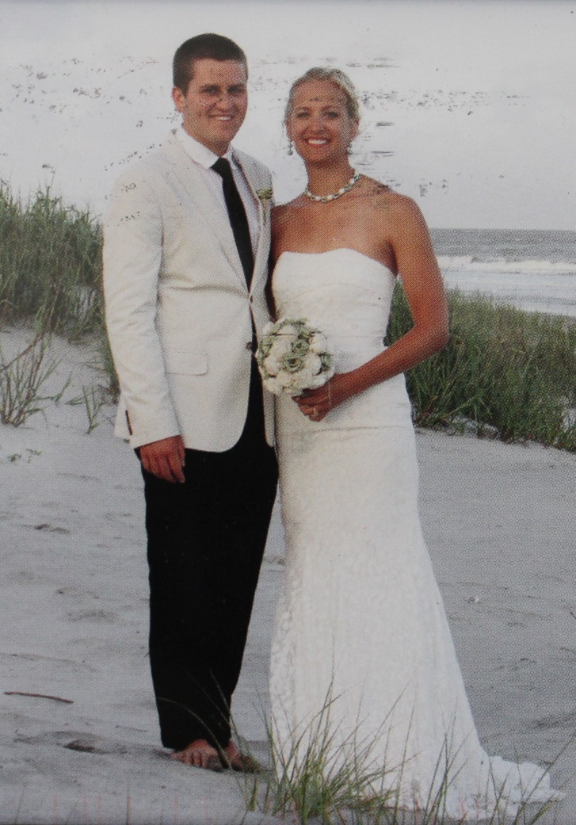

**Joshua David List, Samantha Schumann List, 2013, wedding Folly Beach, S C**